Reflective Essay

During the time spent on this module I have learnt several research skills such as when searching for appropriate references about a particular problem or subject how to quickly determine if a reference will provide me with any useful information that will either help come up with a solution to a problem or lead me to a more relevant source that will. I do this by reading the title then the abstract and the conclusion, this is useful because I do not have to spend time reading an entire article before I decide whether it is appropriate for the task at hand which is much more efficient. In hindsight this could be improved by asking myself what I know about the author, journal, conference etc and research these in order to find out if they are reputable or not which when I look for more sources of information on a topic I am interested in will help me isolate the research leaders in that area effectively improving my research efficiency.

Another research skill I have learnt during the course of this module is if an article is of use to me I will check its list of references for other sources containing information of a similar nature, this reduces the amount of time spent looking for sources of information that will be useful for the task at hand, gives me a better chance of finding reputable sources and allows me to spend more time on the rest of the tasks from the module. This could be improved however by checking how many times a particular reference was cited as the more people who decide to reference that source the more likely it is to be of good academic standard, this will allow me to quickly assess an articles quality before I read it which is a much more efficient use of my time.

A useful research skill I learnt during this module is as I am reading a particular source I will annotate it as I go along, this allows me to put into my own words what a particular source is about which is quite useful as it allows me to quickly write up exactly on the sources content, how it will help me with the task at hand and because I have written it in my own words I will not be plagiarising. However I believe this can be improved by also noting down my thoughts on the articles quality and how it will help me with the task so that when it comes to reviewing said article I will already have my thoughts ready to be written up which is much more efficient.

During the module my group decided in order to better co-ordinate and share information, ideas etc that we would meet on a weekly basis to discuss what we planned to do, how we planned to do it and what was currently being done. This was useful as it focused our efforts on the problem as well as made sure everyone knew their role however sometimes this had to be re-scheduled as often members did not receive emails in time therefore i could improve this by taking the time to ensure good communication between group members early on in the module.

We also decided to keep in touch regarding the ongoing work for the module through regular email conversations which was quite effective as a way of brainstorming several aspects of the module tasks. However I believe that this could be improved if the frequency and content of these conversations were increased to allow greater certainty that all group members grasp the task at hand.

During this module there were some parts of the process that went well and others that did not, it took a very long time to decide on a main and sub questions which led to less time being spent on research and analysis, therefore in future I will consult with the module leader often in order to determine if the chosen main and sub questions are of a good standard which will allow me to spend more time on the rest of the modules tasks. During the module several group members did not behave as expected such as not providing much to group discussions, being uncommunicative etc this led to time being spent backtracking and getting those members up to date, therefore in future I will pre-emptively make sure group members know what they are doing at all times which hopefully will ensure all members are on task and provide more time spent on the modules tasks.

During this module I have learnt much about the ethical and professional research considerations to be taken into account when undertaking a task like this such as data security as if I am to collect and store other peoples data I have to take steps to make sure it is secure such as storing it on a portable hard drive or an offline computer to ensure the data is not stolen also the owner of said data should be informed and given the option to refuse the use of their data. However I believe that I should have also taken into account that if the data is large enough there may be numerous owners and therefore asking all of them for permission to use their data is implausible, in future I should make use of data sets and research into this issue.

In conclusion during this module I have learnt several research skills such as quickly determining whether a source is useful to me, checking a sources list of references and annotating a source as I read it. My group performed well in some ways and not so well in others such as how we scheduled regular meetings, regular email conversations, main and sub questions took longer to decide on than hoped and several group members did not behave as expected. I also learnt the ethical and professional research considerations I should take into account such as the security of any data I gather and store for the task at hand. Therefore I believe I have performed quite well during this module although I have outlined ways in which I can improve that will help me in the future.

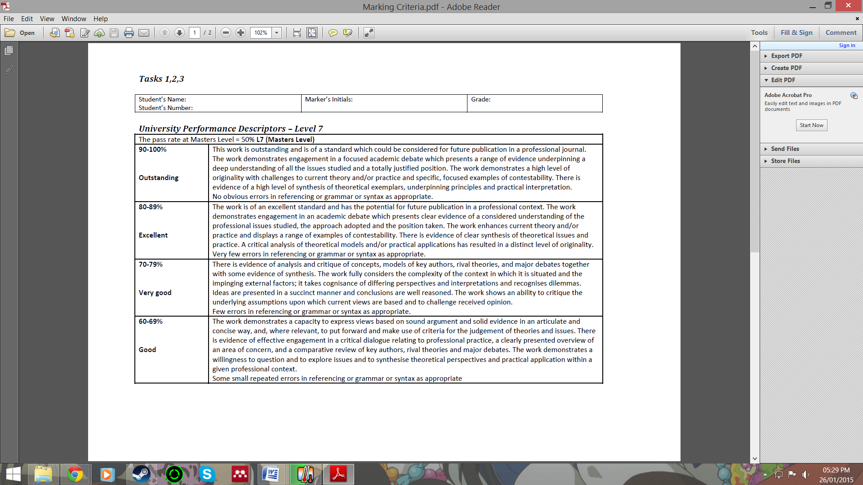

James Braznell

1007022

